CSS 360 – Spring 2015

Professor Valentin Razmov

April 27, 2015

By:

Kalee Flenniken

Chris DuBois

Niki Tran

Bonnie Yip

Rob Stachofsky

Marc Fieser

Interactive Study Tool: LCA Task List

# Team Structure

The team that is working to complete this project consists of six students: Kalee, Chris, Marc, Rob, Niki and Bonnie. As a general team structure, the project has been broken down in parts, and leadership has been spread out for each of these parts. The three main sections of this project include: **Documentation, Application Creation, and Testing.** Kalee will lead the Documentation, Chris and Rob will lead the Application Creation, and Bonnie, Niki, and Marc will lead the Testing.

**Although leaders have been appointed for each of the sections of this project, the goal is to have an environment in which tasks are divided by preference. As this project progresses, the team will get together to decide who wants to take on specific tasks, as well as what tasks group members do not want to take part in.**

**The following is a RACI (Responsible, Accountable, Consulted, Informed) Diagram of the three main components of this project.**

|  |  |  |  |  |  |  |  |
| --- | --- | --- | --- | --- | --- | --- | --- |
|  | **Description** | **Kalee** | **Rob** | **Chris** | **Niki** | **Bonnie** | **Marc** |
| **Documentation** | - Finalize all documents  - Take part in all aspects of writing  - Initialize due dates/ set up documentation meetings with the team  - Turn in documentation on time | **R/A**  Responsibility to ensure that all documentation is updated and completed on time. | **C/I**  Consulted before any documentation has been turned in. | **C/I**  Consulted before any documentation has been turned in. | **C/I**  Consulted before any documentation has been turned in. | **C/I**  Consulted before any documentation has been turned in. | **C/I**  Consulted before any documentation has been turned in. |
| **Application Completion** | - Talk with the group about environment/setup  - Help divide tasks for completion  - Initialize due dates/ set up documentation meetings with the team  - Reach out to testing upon completion of each step | **C**  Consulted when each step of the application is complete. | **R/A**  Main Page Completion  Quiz page creation  Drop down menu creation | **R/A**  Main Page Completion  Quiz page creation  Drop down menu creation | **C/I**  Consulted when each step of the application is complete.  Informed when/how to add questions and topics | **C/I**  Consulted when each step of the application is complete.  Informed when/how to add questions and topics | **C/I**  Consulted when each step of the application is complete.  Informed when/how to add questions and topics |
| **Testing** | - Talk with the group about issues found through testing  - Help divide tasks for completion  - Reach out to team members in application writing to encourage completion  - Reach out to testing upon completion of each step | **I**  Informed when each stage of testing has been completed | **I/C**  Consulted throughout the testing and informed when each stage of testing is complete | **I/C**  Consulted throughout the testing and informed when each stage of testing is complete | **R**  Responsible to test all functionality of each stage of application  creation | **R**  Responsible to test all functionality of each stage of application  creation | **R**  Responsible to test all functionality of each stage of application  creation |

# Tentative Schedule And Milestones

To view the Updated Task List up close, please refer to the Excel workbook titled: *Interactive Study Task List V3*

*Changes have been made to highlight the completion of tasks in Interactive Study Task List V3.*

Below is a screen shot of the task list for the next three weeks.

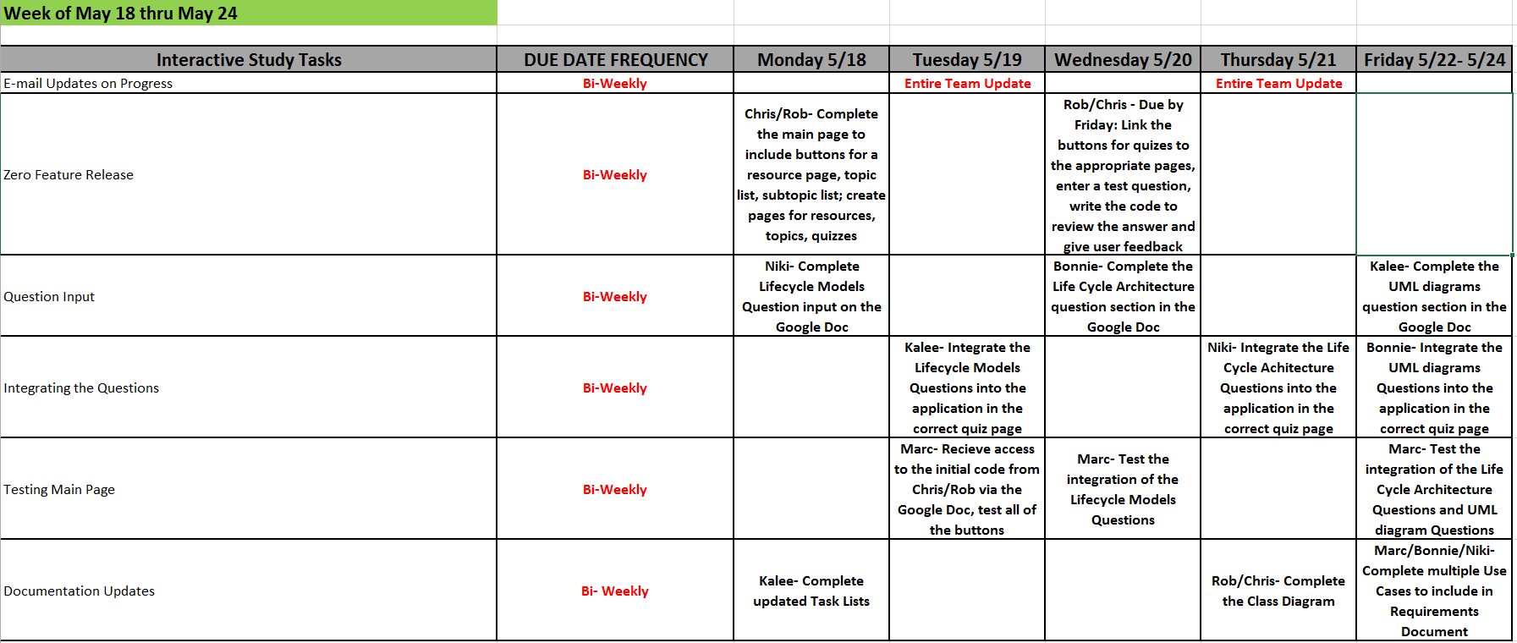

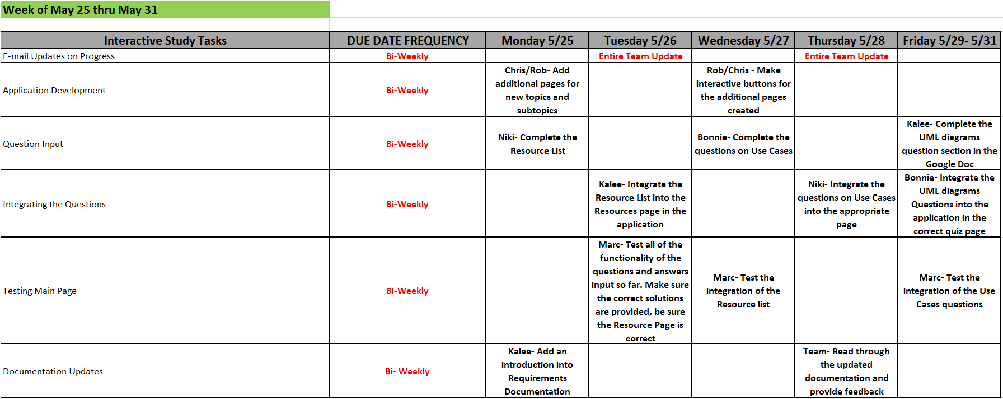

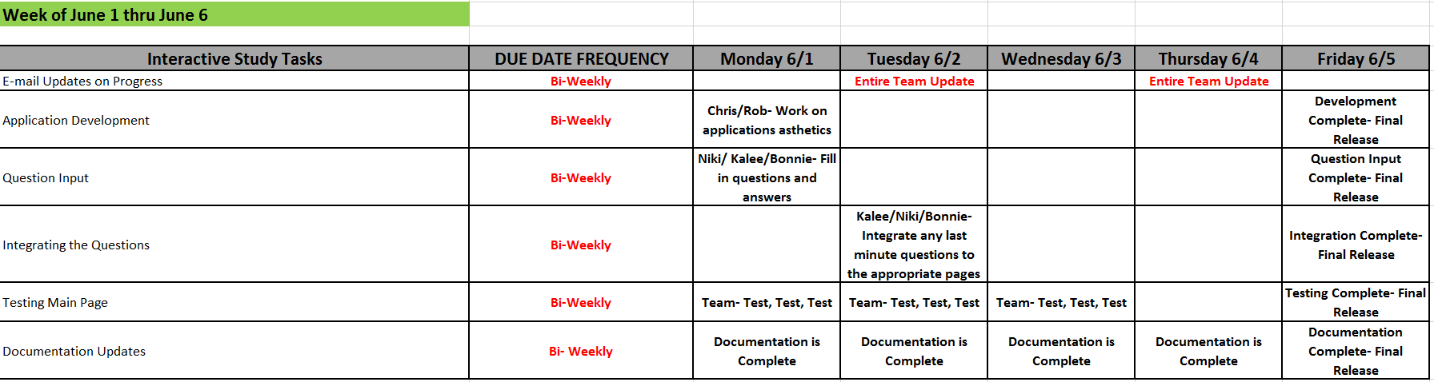

Below is an overview of the timeline and how all aspects work together:

**Specifics of the Tasks and Milestones:**

**Documentation:**

**Milestone 1:** LCO Proposal:

This document is a rough draft of the operational concepts, system requirements, architecture, feasibility rationale, and life cycle plan. It is the foundation of this application.

Feedback on LCA Document:

The LCA document is similar to the LCO document, but it contains much more detail, as well as a

Detailed task list and schedule for each aspect of this project. The LCA will also have a testing plan.

Progress Reports:

There will be multiple progress report dates for the duration of this project. The purpose of the progress reports is to have a detailed conversation with the team that will include: individual progress made, any inconsistencies, problems, suggestions, as well as offering support.

**Milestone 2: LCA Document V2:**

Updates will be made on the original LCA documentation to account for the updated task list and any changes made to the test plan.

**Application:**

The design of the application will be described in detail in: *Interactive Study Tool LCA Requirements, Specification, Architecture_V2*

Main Page Completion:

The main page of the website will have a brief description of what this website is (ie a study website in which the user can select a topic/subtopics from a drop down menu and begin to answer questions on that topic. The main page will initially be a skeleton in which the functionality will be tested. Upon completion of the testing, a theme will be added to the main page to make it visually appealing to the customers.

Drop Down Menu:

The drop down menu will be located on the main page of the website as well as a separate page that will be created to give the users an idea of what topics are offered on this website. Initially, the drop down menu will be tested with one topic. Upon completion of this testing, and completion of the first topic, additional topics will be added to the drop down menu and tested accordingly.

Question creation:

The questions will be created for each topic in the drop down menu. These questions and answers will be tested to ensure basic functionality and correctness. Upon completion of the first topic, subtopics will be added and tested. The goal is to have each topic contain subtopics that have quizzes.

Additional Topics:

Additional topics will be added to both the drop down menu on the main page and the separate topics page. The additional topics will be completed first with the input of questions and tested for functionality. Upon completion of these tasks, the topics will be broken down into subtopics and tested accordingly.

**Milestone 2: Beta Release (Partnered with documentation updates as described above)**

Upon completion of the main page and initial topics and subtopics, the application will have a beta release. The target audience of the beta release will be a select group of students at UWB. These students will be given a web address to access the application in order to participate in browsing through the pages and taking the quizzes.

**Milestone 3: Final Release**

Upon incorporating feedback from the target audience via the beta release, necessary changes will be made and additional testing will be performed before the application has its final release.

**Testing Overview:**

The testing will occur after every step in the application creation process. The main page will be thoroughly tested before moving on to the creation of additional pages and topics. Furthermore, once the topics are created and the questions are input, each topic will be tested thoroughly before continuing to input the next one. The testing is explained in detail in the document: *Interactive Study Tool LCS Test Plan*

**Features that have been moved to Version 2 Release: (Added to V3 Task List Document)**

**Additional Topics and Subjects:**

Many more topics and subjects must be added to this application to appeal to a larger target audience.

**Integrating the questions and answers into a database:**

To make use of large amounts of questions and subjects, hard coding the questions will need to be replaced by external storage (a database)